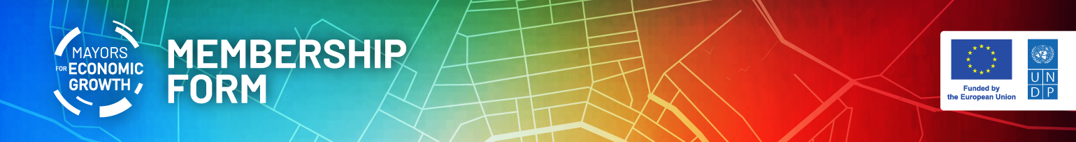

M4EG MEMBERSHIP FORM

I, [Name of the Mayor], [Mayor] of [Name of the local authority] have been mandated by the [City Council/Assembly] on [date] to sign up to the Mayors for Economic Growth (M4EG) Facility, in full knowledge of the commitments set out in the Mayors for Economic Growth Concept summarized below.

Therefore, my local authority principally commits to accelerate sustainable and inclusive local economic growth, development and job creation by designing new local interventions bringing together residents, the business and civil society communities.

By signing this form, my municipality displays the strong intent to:

- Explore means toward a ‘purpose oriented’ economic approach, designed in the public interest, that addresses the key development issues within my municipality. This would inter alia entail ensuring a gender perspective and the overall inclusivity agenda, environmental dimensions and the climate limits, the role of new technology, as well as the changing behavior patterns and realities post-COVID-19 pandemic.
- Develop a coalition/platform/space with residents, the private sector and civil society groups and new actors to co-design a new generation of Local Economic Development Plan or its equivalent, consistent with the guidelines communicated to me by the M4EG Secretariat, and to implement, iterate and adapt the LEDPs in line with the principles of good governance and sound financial management.
- Apply the core principles of good governance especially in terms of accountability, transparency, anti-corruption, and inclusion.
- Actively engage in sharing of learning and knowledge within the M4EG Facility in the Eastern Partnership countries, including report progress on the implementation of the Plan and lessons learned to the M4EG Secretariat, housed within the respective UNDP Country Office.
I am informed that my municipality shall be suspended from the M4EG Facility, subject to prior notice in writing by the M4EG Secretariat, in case of non-adherence to the above-mentioned intentions, and documents (i.e. the new generation Local Economic Development Plan and reporting requirement) within the established deadlines. I am also informed that my municipality may leave the M4EG Facility based on prior notice submitted to the M4EG Secretariat.

[Name of the Mayor] [Signature]
[Name and complete address of the local authority]
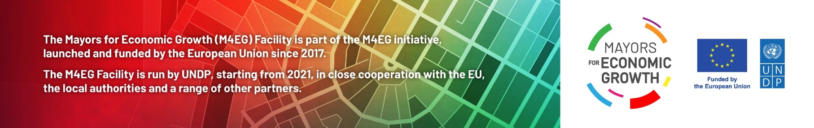
[Name, e-mail and phone number of the contact person]

